Aws EC2 service on windows Steps:

1. Download the .pem key.
2. Using putty generator convert it into .ppk key.
3. 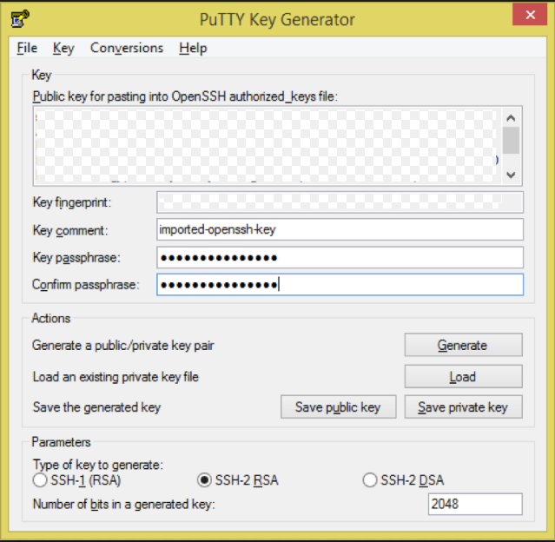

Click on load and add .pem file convert them into ppk file.

After that call putty terminal

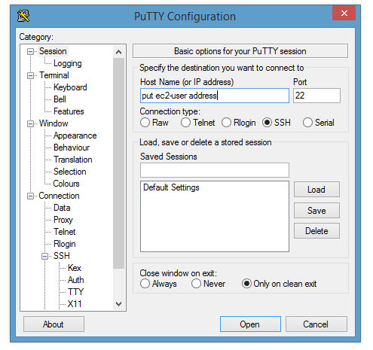

Add host name and open it

Then add login user name

Access your instance.